WELLIES 4 WORK
This list was created at a Mini Conference in partnership with
The European In Green Shape Project,
with participants from UK, Austria, Lithuania. Bulgaria and Italy.
Groups were asked to suggest ideas for small businesses that could be set up easily with no or little financial outlay. Some, but not all of the ideas would need training and also to follow the relevant legal requirements, such as Food Safety.
- Bath and beauty products- soaps, cosmetics etc.
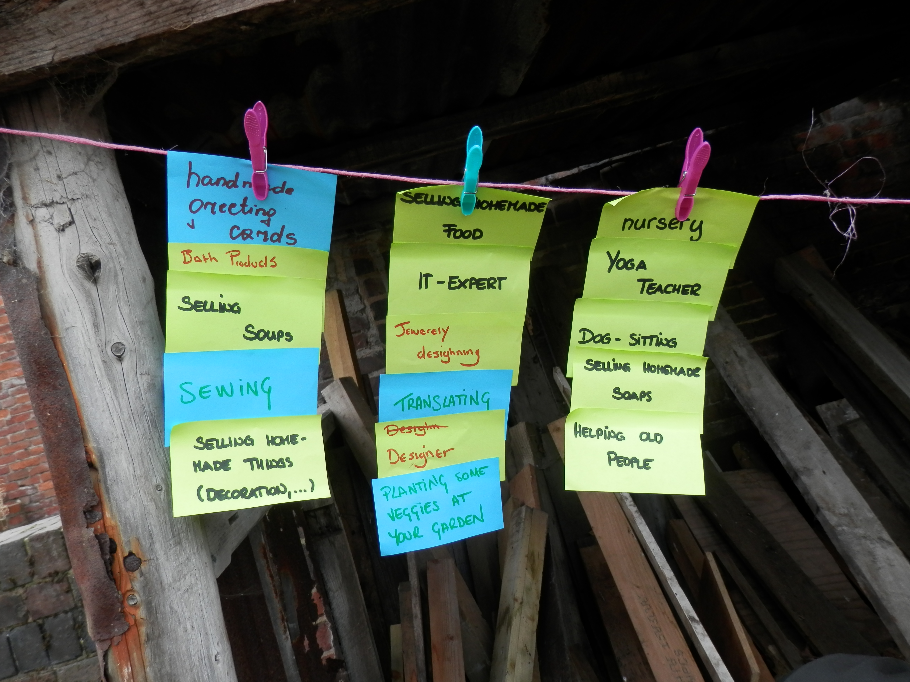
- Beautician
- Beta tester (Software Testing)
- Car wash/valet
- Carer
- Child minder and school transport
- Christmas floristry- holly wreathes
- Cleaner
- Coffee/tea mornings (Mobile)
- Complementary therapy (Reiki, Yoga)
- Cook
- Counselor
- Crafts/hobbies – making to sell or running workshops/one to one tuition
- Creating creative things (Baskets, Bags For Phones/Tablets).
- Decorator
- Decluttering and organisation
- Designer (Website, Graphics, Interior)
- Dog groomer
- Dog trainer
- Dog walker
- Escort
- Florist
- Fortune teller (Tarot/Clairvoyant)
- Gardener- lawn mowing, weekly service, seasonal tidying etc.
- Greeting cards (handmade) or selling for commission through a company such as Pheonix Cards or similar
- Growing plants (Flowers, Vegetables)
- Hairdresser
- Handyman
- Home made food- ready meals for busy people or the elderly
- House sitter
- I.T. Expert
- Jewelry (Design, Making).
- Knitting
- Laundry/ironing service
- Local guide
- Looking for promotions
- Making and selling handmade dog biscuits
- Making herbal teas
- Mystery shopper
- Nursery
- Organiser (Wedding).
- Personal assistant
- Pest management/control
- Proof reader
- Rural arts & design
- Secretarial and admin work (Data Input)
- Sewing (bespoke outfits)
- Soup making (Soup Kitchen)
- Telesales
- Translating
- Tutor (Guitar, Homework Help, I.T.).
- Virtual assistant
- Window cleaner
- Writer
